**ASSIGNMENT:**

Design and implement a microservices architecture using .NET Core. Your solution should include at least two microservices that communicate with each other via a message broker. Each microservice should have its own data storage and be designed to handle a specific business domain or functionality. Your solution should also include a service registry and a circuit breaker to handle service failures. Provide detailed technical documentation of your implementation, including diagrams and code.

**SUBMISSION DATE:**

6-03-2023

Answer

There are three types of architectures

1. Monolithic
2. N Tier
3. Microservices.

**Monolithic Architecture:**

Monolithic architecture is traditional or most commonly used for developing the application. In this approach, all the business units or logic are implemented under a single application. A single database can be used for data serving.

[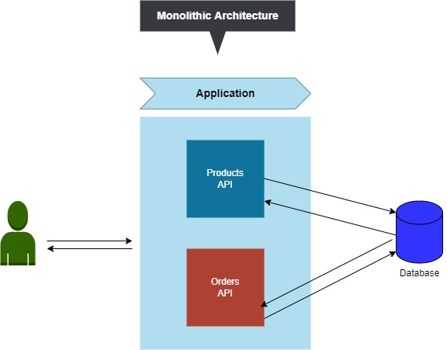](https://blogger.googleusercontent.com/img/a/AVvXsEhyuLZ9kN2BDCoxUShv3DZN0VouqcriA6L1LxVcsJEHr3EpvfPNMC0r6i2Vuh2ed7u2LC5nXVKHKlx2H-FsXvy95IlGMvYKQW5C1ThiaZWbhjR0lTgkF5oY1kF7pNL4eW697e64VD2ytlHFXzhm3T7fzDl7HfOi7mdBUmzSu127Lew1ditM6HFixQ97=s576)

**Microservice Architecture:**

In Microservice architecture each business unit or logic is developed as separate small individual applications. So each separate application is lightweight and they have their own responsibilities to carry on and these individual services are called Microservices.

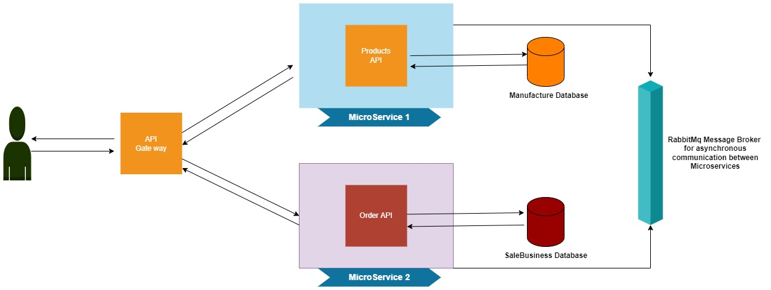

Here is the blueprint of the Microservice architecture and the same microservices I am going to implement for this Assignment

You can observe 2 microservices each has their own responsibilities like 'Product API', 'Order API'.

Each microservice has its own database for data flow.

Established asynchronous communication between the microservices by implementing a Massage Broker channel of RabbitMQ.

Each microservice have their own domains which will be a hard time for a client application to maintain, this problem can be overcome by using the 'API Gateway'. The API Gateway where we can register all the endpoints of the microservices and API Gateway also had its own domain. So client application invokes the API Gateway endpoint which implicitly communicates with microservices and then serves the response to the clients.

**Implementation Part.**

Please note these databases are created manually or from scripts I cannot use EF Core for this for simplicity of the assignment.

Databases scripts are uploaded with the Source code of the Project link below.

[ashahzad007/MicroServicesExample (github.com)](https://github.com/ashahzad007/MicroServicesExample)

I have created two databases in the SQL Server with the name of

1. **Manufacture**

In manufacture database I have created only one table of **products** which has the following fields

Id, name , cost , description and created date.

1. **Sales Business**

In sales business database I have create two tables

1) **Orders**.

In orders tables I have added Id, userid , productid(works as foreign key of Manufacture

data base Product Table ) , orderdate

2) **Products**.

In Product table I have added , Id , and Name fields.

**Visual Studio (.Net 6)**

### I have created three Microservices to achieve this assignment

### Microservice For The Products Endpoint Manufacture API with Implementation of the HTTP GET, HTTP Post , Read and Write Operations

### Microservice For The Orders Endpoint Sales Business API with Implementation of the

### HTTP GET, HTTP Post , Read and Write Operations

3) API Gateway with using Ocelot.

### Asynchronous Data Communication Between Microservices

### To achieve this , I have used RabbitMQ Message Broker With MassTransit

### I have also install Docker-Desktop Locally into my machine.

Steps I have taken to accomplish this assignment are:

* Configure RabbitMQ message broker with MassTransit for asynchronous data communication between the microservices.
* In the 'Manufacture' database we have a 'Products' table(like Master table), now we will create a new 'Products' table(like child table) in 'SalesDatabase', but here we will add only required columns. So that while fetching the 'Orders' endpoint it is to fetch required products information.
* So with help of RabbitMQ, we always maintain consistent or exact data between both parent and child tables.

**Last Step configure API Gate Way.**

I have implemented API Gateway for our microservices to define a unified URL with that all client applications can consume it instead of consuming individual URLs of the microservices.



**Need Of API GateWay?:**

Consider our microservice where we have two microservice applications. The 'Manufacture.API' application runs at 'https://localhost:7132' and The 'SalesBusiness.API' runs at 'https://localhost:7456' so from this we can understand we have 2 different domains bound to our each microservices.

In the real-world application, we may deal with 10 plus microservices base on our business. handling or managing or consuming 10 plus different domains by a client application is very hard.

To solve this problem API Gateway comes into the picture. API Gateway is also a simple API project with its own domain. But we will register our microservice URL with our API Gateway URL with appropriate Paths. So now will expose only API Gateway URL to the clients. when client calls Gateway API endpoint behind scenes API Gateway invokes appropriate microservice URL based on URLs registered with, on receiving the response from microservices, API Gateway delivers the same response to the clients.

**Ocelot API Gateway:**

Ocelot is an open-source API Gateway built on top of .NET Core. It can be used to unify all microservices endpoints.

**This Assignment is Completed and Tested in My Local Host Environment. Please follow the link below to find its Git Repository for more detail information.**

[ashahzad007/MicroServicesExample (github.com)](https://github.com/ashahzad007/MicroServicesExample)

You need to install docker-desktop other packages like ocelot , RabbitMQ message broker along with MassTransit.

For any other Information about this assignment, contact me on my email or my cell numbers

Best Regards

Amir Shahzad

ashahzad007@outlook.com

Cell: 03098881701

Cell: 03314234440